GCS sourced content for Small Business Saturday

South West

https://www.youtube.com/watch?v=D-OU9FiGO0g&feature=youtu.be
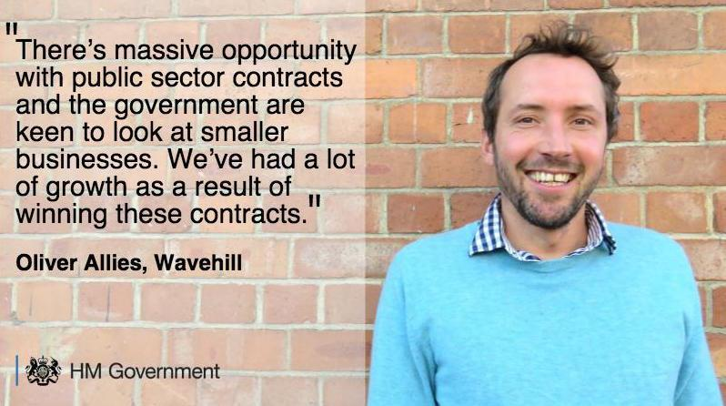
Working with the public sector can help your small business grow: gov.uk/contracts-finder #SupplyGov #SmallBizSatUK

